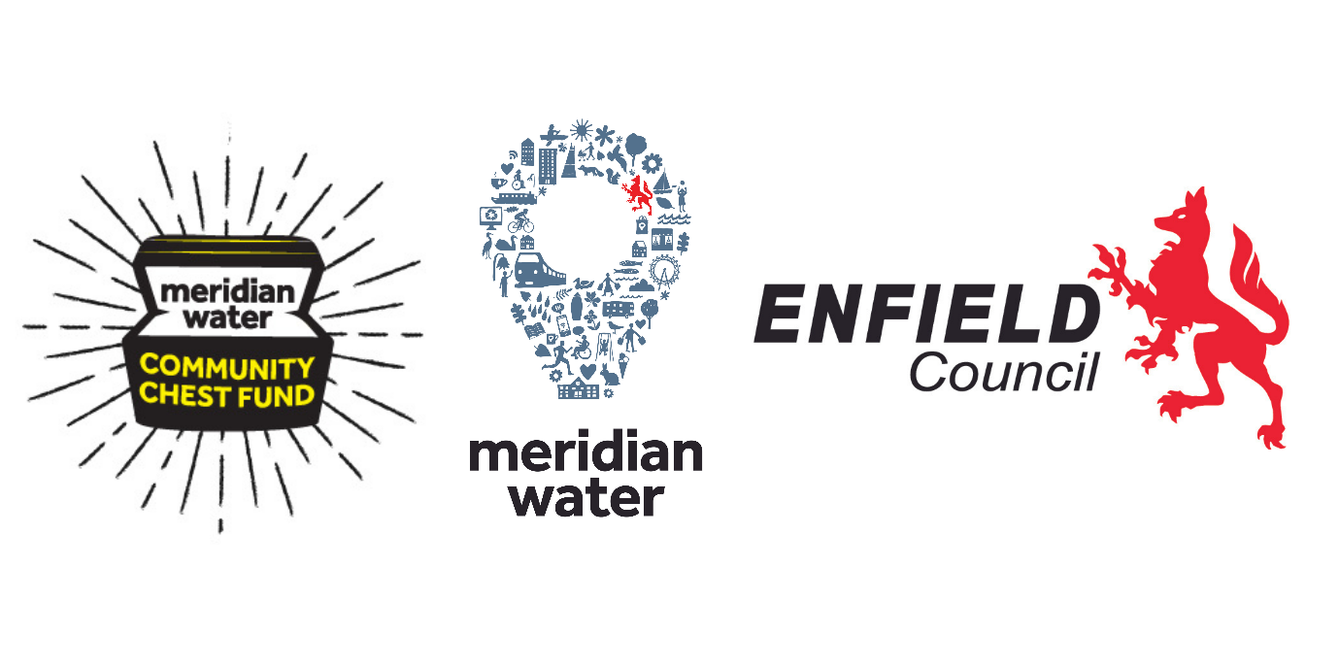
The Meridian Water Community Chest – small grants fund background, guidance and application form:
Background:
The Meridian Water Community Chest Fund is a new fund that has been set up to help improve neighbourhoods closest to Meridian Water in the wards of Upper Edmonton, Edmonton Green and Lower Edmonton. These three Edmonton Wards in Enfield are amongst the most deprived in the UK and to help bridge the gap towards other parts of the Borough, the Council wishes to ensure that residents local to the Meridian Water development are the primary beneficiaries of the benefits brought about by the investment into the area.
As the Meridian Water development moves forward in delivering new homes, new infrastructure, new public realm and community facilities, developers and contractors to the project are currently contributing into this new Community Chest fund that you can now apply for. Further contributions are expected through the lifetime of the scheme.
We are now inviting bids for a share of the new grant fund to help fund Edmonton focussed community projects. The fund will provide grants to organisations or groups of individuals who come together to deliver community-led projects in the three Edmonton Wards.
The Meridian Water Community Chest Fund can be used to help deliver a wide range of projects (both capital and revenue) and we want to fund projects that will make a real difference to the lives of local people and their community.
Fund allocation & evaluation protocol:
The fund is open to bids from not-for-profit external stakeholders to the Council (such as faith groups, schools, community groups and charitable organisations). You may not be a formally constituted group – Tenants and Residents Associations, Parents and Teachers Associations, even a group of residents with a common cause can come together to apply for this small grants chest – as long as you have a written Terms of Reference for your group.
There will be an initial bidding round with further rounds dependent on the take up during this first round and further contributions paid into the fund.
Around £100,000 will be allocated to 'small' grants for more informal local based groups initially (depending on number of bids received). These grants can be up to £2500 in value and information, guidance and criteria specifically for these smaller local grants are as below.
(If you wish to bid for funds above £10k, the details are here: www.meridianwater.co.uk/community)
Final decisions on funding allocations will be made by the Executive Director of Place upon recommendation of the Meridian Water Community Chest Community Panel, with representation from Senior officers of the Council alongside representation from community groups based in each of the three Edmonton Wards. All applications will be assessed to ensure they meet the key eligibility criteria as set out.
The decision of the Executive Director of Place and this panel is final. There is no appeals process. Unsuccessful candidates will be given feedback and amended applications can be submitted to another round. Details of the projects to receive funding will be published on our website.

Support with project planning can be accessed through Enfield Voluntary Action https://enfieldva.org.uk/ with advice from a dedicated Community Accountant and Development & Funding Adviser: Please email f.adams@enfieldva.org.uk
Grant payments will be made to successful small grant applicant organisations as follows: Three quarters on signing of legal binding grant contract agreement; one quarter on receipt of evidence of expenditure, project delivery and monitoring visit at the end of the project.
NB - all successful applicants will be required to promote the project and acknowledge the Councils funding. This must be included in the promotion of their project and their work including photos or physical outputs. The source of the funding will be set out in promotion, linking projects to donor organisations wherever possible.
Core Eligibility Criteria:
To be eligible, your proposed project must meet the following criteria:
- Bids must exceed the minimum threshold of £1000 and must not exceed the maximum funding threshold of £2,500.

- The delivery of this project is contingent on funding from Enfield’s Meridian Water Community Chest Fund.

- No Council departments can apply. Projects must not directly benefit individual councillors.

- Individuals or for-profit businesses will not be considered (A group of individuals can come together under the banner of a project ‘terms of reference’ under this small grant pot).

- MW Community Chest cannot be used to fund the same project twice

- Whilst the fund can cover project related overheads, salaries or rent, the proposed project should not have significant ongoing financial/revenue implications, such as long-term maintenance or ongoing retained staff costs (except where it can demonstrate how on-going running costs can be funded from other sources).

- Must propose a project that delivers a clear community benefit within one, two, or all three of the Edmonton Wards of Lower Edmonton, Edmonton Green or Upper Edmonton AND be submitted from an organisation or collective based within one of the above wards. (The focus on Edmonton is derived from the clear need expressed by the national Indices of Multiple Deprivation and the 2020 Enfield Poverty Commission Report. Meridian Water sits within these communities and the stated aim for Meridian Water that ‘local people are the primary beneficiaries of the benefits from the development’). Applicants from organisations based outside the Edmonton Wards but for a project benefitting Edmonton residents are advised to look at applying for the larger grants programme: www.meridianwater.co.uk/community

- Must address at least one of the following themes from the 2020 Enfield Poverty Commission Report “All things being Equal”:
- Improving a physical area within a community
- Improving opportunity for local people, particularly around employment & skills
- Improving life chances for young people
- Addressing health inequalities

Some example projects in these categories could be:
- Addressing security and crime, improving the look and feel of local streets & the public realm or adapting an area to make it more climate change adaptable;
- Addressing equality, diversity and inclusion including employment and skills issues, language barriers, upskilling and retraining programmes, linking to Meridian Water opportunities – particularly cultural and creative activity;
- After school and homework clubs, work experience and placements, paid internships, enhanced and diversified education provision;
- Extended health and wellbeing provision, healthy eating classes, exercise classes, activities for elderly residents, young mothers etc

- Any application proposing work with young people will have to prove safeguarding is in place.

MW COMMUNITY CHEST SMALL GRANT APPLICATION FORM:
Submission number
(Office use only):
To help us evaluate the suitability of individual projects, applicants will need to provide relevant information within the form below to demonstrate how the project will be delivered and implemented, as well as a brief rationale describing the goals and outputs of the project.
Applicants are also encouraged to submit visual evidence (e.g. photographs and illustrations) as part of your bid, alongside this completed form.
All funding bids must be made using the application form below. Please complete all sections of the form and submit it along with any other relevant information (e.g. any other electronic material to support your bid) to meridianwater@enfield.gov.uk before 5pm on Thursday 23rd December 2021. Unfortunately, late applications will not be accepted.
Project description (100 words max)
Title:

Name of Organisation / Group:
Type of Organisation / Group:

Project lead and contact details
Name:
Address:

Daytime Telephone Number:
Email address:

Bank Account Details:

Description: Vision & goals of your project

Applicants will need to provide a broad description of the project and the statement below should also provide a summary of what the project is aiming to achieve and what success will look like.
Please describe your project IN NO MORE THAN 500 WORDS, how it will meet an identified local need and what will your successful project look like? :

Under which Poverty Commission Report recommendation theme does this project fall:
Physical improvements
Local opportunity
Employment and Skills
Young people
Health and wellbeing

How many local residents will benefit from your project (roughly) ?

BUDGET PLANNING:
Funding applications will need to include a full estimate of the project’s cost
Total estimated cost of the project:
Total Funding sought from the MW Community Chest fund:
Is this Capital and/or revenue funding?

Please break down these overall figures into a rough budget:

How will your project offer good value for money?
This fund seeks to support projects that will have a long-lasting positive impact and will continue to deliver benefits to Edmonton communities, especially those on low incomes.
Projects should be self-sufficient/sustaining and should not impose additional costs on the council and other relevant partners.
Projects must also comply with relevant policy and legal requirements (for example, on road safety, planning policy and environmental health).
Please explain how your project will offer value for money below:

Who will deliver and manage this project?
Funding bids must provide details of how the project will be delivered and managed over its lifetime. This includes:
- the name of the lead person, partner or organisation (who will manage the day-to-day running of the project); and
- any other relevant delivery partners (e.g venue provider):

Please explain how the project will be delivered and managed here:

Can your project be delivered on time and budget?
In this section, applicants will need to provide a very brief timescale of the overall project (including indicative start and end dates and any key milestones).
Please provide a timeline of your project and a breakdown of key milestones here:

Part C: Next steps

Once applications have been submitted, projects that are eligible to receive funding will be assessed and evaluated against the criteria set out.
Please note that this funding is limited so not all eligible bids will be accepted. Every application will be considered on its individual merits.
As outlined, a panel of advisors comprised of the Executive Management Team from the Council (including representatives from People, Place, Resources and Chief Executive's department) and three community groups, representing each ward will receive and recommend bids suitable to be progressed. The final awards will be approved by the Executive Director of Place and successful projects will be notified. Details of the projects to receive funding will also be published on our website.
Where bids are successful, applicants will need to keep us informed about the progress of their project once the funding has been made available. This will include providing information on progress against the outcomes, defined by the bidder.

